**Name: Akshat**

**Module -1: Understanding of Hardware and Its Components**

Section 1: Multiple Choice

1.Which of the following is NOT a component of the CPU?

1. ALU

2. RAM

3. CU

4. 1 and 3 both

Ans: Ram

Reason: The cpu consist of alu(arithmetic logic unit) and cu(control unit).

2.What is the function of RAM in a computer?

Ans: ram is a computer's short-term memory. It stores data and instructions the cpu needs while tasks are running.

3. Which of the following is a primary storage device?

1. HDD

2. SSD

3. SD card

4. 1 and 2 both

Ans: HDD and SSD

4. What is the purpose of a GPU?

Ans: TO make graphics and images rendering faster and smoother. It is mainly used for gaming, video editing, ai , and 3D design.

Section 2: True or False

5. True or False: The motherboard is the main circuit board of a computer where other components are attached.  
 Ans: True

6. True or False: A UPS (Uninterruptible Power Supply) is a hardware device that provides emergency power to a load when the input power source fails.  
 Ans: True

7. True or False: An expansion card is a circuit board that enhances the functionality of a component.  
 Ans: True

Section 3: Short Answer

8. Explain the difference between HDD and SSD.  
Ans: HDD uses spinning disks to store data, making it slower and more shock-sensitive , but cheaper.

SSD uses flash memory making it faster, quieter, and more durable than HDD, higher cost per gb than hdd.

9. Describe the function of BIOS in a computer system.  
Ans: The BIOS (Basic Input/Output System) initializes and tests hardware components during startup and loads the operating system from storage into memory.

10. List and briefly explain three input devices commonly used with computers.

Ans: (i) Keyboard - Text aur commands entry.  
(ii) mouse – point and click navigation.  
(iii) Webcam – videos , images .

Section 4: Practical Application

11. Identify and label the following components on a diagram of a motherboard:

● CPU

● RAM slots

● SATA connectors

● PCI-E slot

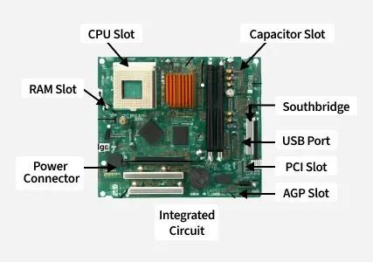

* CPU – cpu socket
* RAM Slots – Long vertical slots near CPU
* SATA Connectors – Small ports on the side(L shaped)
* PCI-E Slot – Long horizontal slot for graphics card

12. Demonstrate how to install a RAM module into a computer.

Ans: Step-by-Step Process:

1. Turn off the pc

Shut it down and unplug the power cable.

2. Open the case

3. open DIMM slot latches

4.align module notch with slot key

5.press firmly until both latches click closed

6. close case ,power on.

Section 5: Essay

13. Discuss the importance of proper cooling mechanisms in a computer system. Include examples of cooling methods and their effectiveness.

Ans: Why Cooling is Important in a Computer.

1. Computers get hot

When your computer works parts like the CPU and GPU become hot.

2. Too much heat is bad

If it gets too hot, the computer can:

* Slow down
* Crash or shut down
* The components can get damaged over time

Cooling Methods

1. Air Cooling (Fans)

* Uses fans to blow hot air out and also for cooling intake
* Example: CPU fan, case fans, GPU fans

2. Heat Sinks

* Metal blocks that absorb heat from CPU/GPU
* Work with fans to cool down faster

3. Liquid Cooling

* Uses water or coolant to carry heat away
* Better than fans for high performance PCs
* Quieter but more expensive
* Used by gamers or video editors

4. Thermal Paste

* A special paste placed between CPU and heat sink
* Helps transfer heat better
* Small but important

14. Explain the concept of bus width and its significance in computer architecture

Ans: A bus in a computer is like a road that transfers data between parts of the computer.

Like:- CPU, Memory, Storage devices

Important: -

1. Faster Data Transfer
2. Better CPU-Memory Communication
3. Improves Overall Speed

Example: -

A 64-bit bus can transfer 8 bytes at once.